# Project Perceiving the World through Technology Milestone 4 - Deployment

Navigna Reddy Gangumalla

Nehal Anilkumar Kathiriya

Aditya Dixit

**Description of the product**

The goal of the project is to create a portable sensor system that will assist visually impaired individuals in navigating their surroundings with more ease and safety.The system consists of two sensors, an IR obstacle avoidance sensor and a tilt-switch sensor, as well as a buzzer and vibrating motor that serve as feedback components.

The IR obstacle avoidance sensor is designed to detect objects in the user's path and issue a warning through the buzzer component when it detects an obstruction. This allows the user to avoid collisions and safely navigate around the obstacle.

The tilt-switch sensor detects changes in the user's orientation and balance and alerts them through the vibrating motor component. This feature is particularly useful in preventing falls and maintaining balance, as the user can quickly and easily adjust their position to avoid any potential hazards.

Both sensors are portable and can be attached to a fanny pack for easy access and use. The system is designed to be user-friendly and accessible, with simple feedback components that allow the user to quickly and easily understand any potential hazards or changes in their environment.

**Text description**

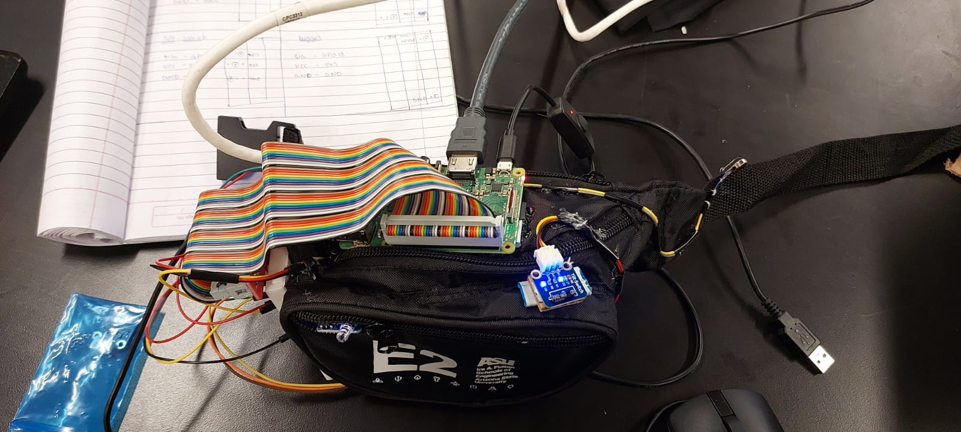

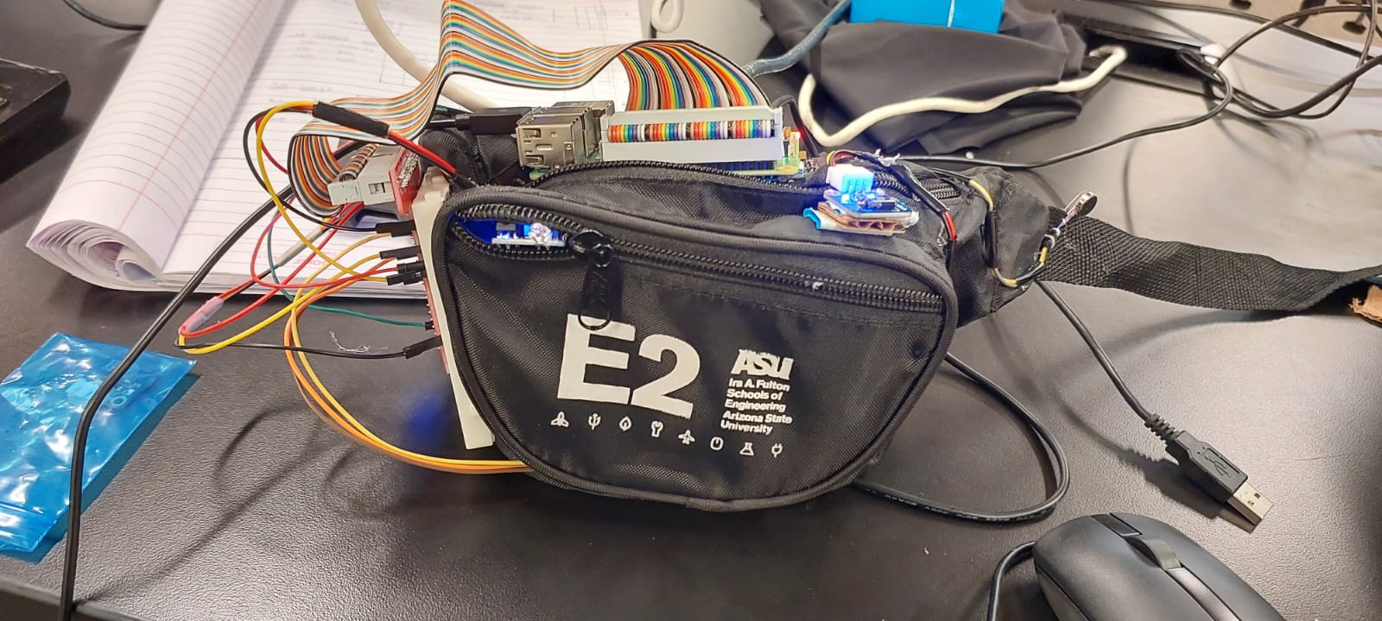

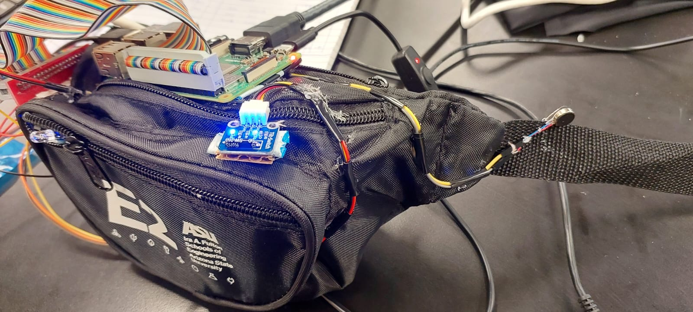

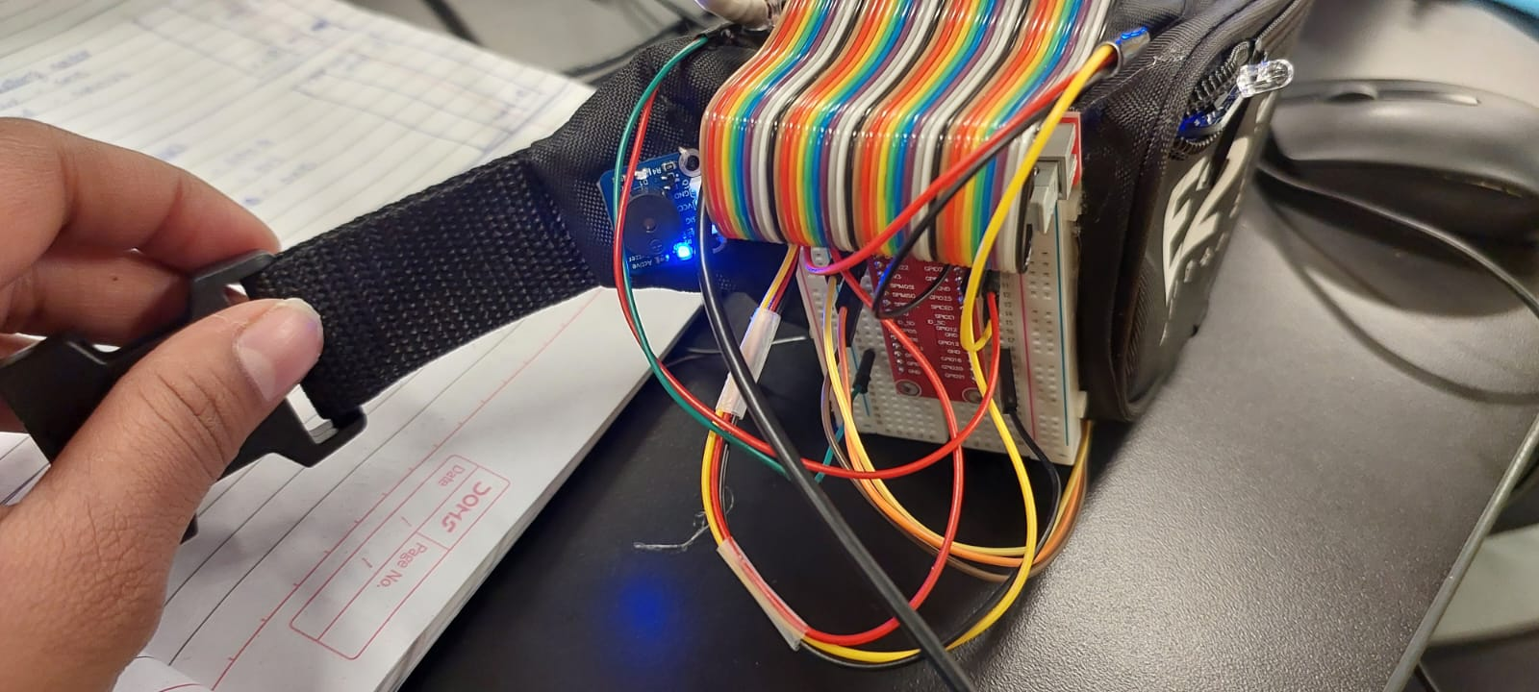

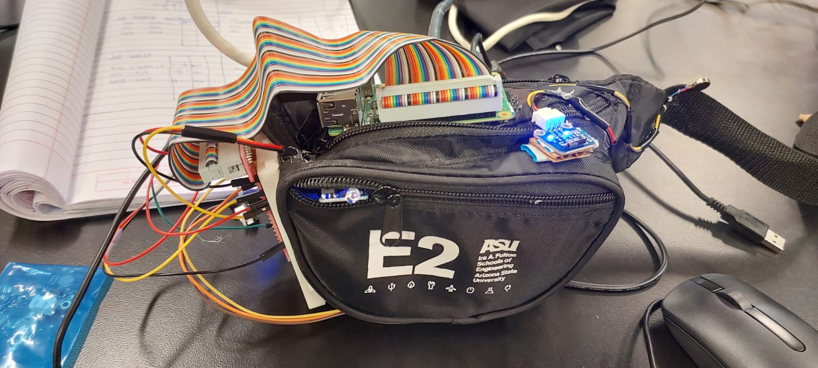

**Features**

Wearability features:

* Adjustable waist strap to accommodate various waist sizes
* Easy to put on and take off, with no complicated closures

Portability features:

* Compact size to reduce bulkiness and improve mobility
* Multiple compartments to store and organize personal items

Fashionable features:

* Can be worn as a fashion accessory, rather than solely for functional purposes.

**Interaction/Feedback**

The interaction of the IR obstacle avoidance and tilt-switch sensors and their feedback components work together to provide the user with comprehensive information about their surroundings. When the IR obstacle avoidance sensor detects an obstruction in the user's path, the buzzer component issues a warning to alert the user of the potential collision. At the same time, the tilt-switch sensor detects any changes in the user's orientation and balance and alerts them through the vibrating motor component. This feature helps the user maintain their balance and avoid potential falls, especially in situations where they may not be able to see potential hazards.

Input sensors: 1.IR Obstacle avoidance sensor

2.Tilt-switch

Output sensors: 1.Buzzer

2. Vibrating motor

**State Diagram**



**Functionality of your product:** Link is given below

<https://youtube.com/shorts/xIuvTYqCm6s?feature=share>